APER CPD Record | version 1.1
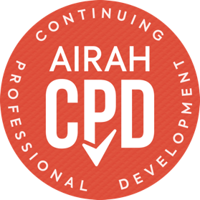
Summary of activities claimed as continuing professional development
Use the table below to record your CPD hours. If you have recorded your CPD using your online CPD Diary,
please download your diary records and submit them as a separate document. You may be requested to
provide further information supporting your CPD claims at the time of your assessment.

Date | Knowledge area  (TECHNICAL, LEADERSHIP, BUSINESS, or PERSONAL) | CPD provider name | Activity title/description | Activity type  (see below for descriptions) | Hours

Date | Knowledge area  (TECHNICAL, LEADERSHIP, BUSINESS, or PERSONAL) | CPD provider name | Activity title/description | Activity type  (see below for descriptions) | Hours
Total of all types:
(150 hours required)

Activity | Activity | Description | Maximum allowable hours  in a 3-year period
Type 1 | Formal post-graduate education | At a higher learning institution. | No limit
Type 2 | Professional development education | Formal training programs supplied by RTOs and education providers; includes courses such as AIRAH’s Professional Diploma of Building Services. | No limit
Type 3 | Conferences and technical meetings | Attendance or participation at conferences and technical meetings. | 60 hrs
Type 4 | Leadership positions | With AIRAH or allied organisation Committees, Boards, and Technical Groups. | 150 hrs
Type 5 | Speaking (presentations) | Technical presentations at conferences and events. | 75 hrs
Type 6 | Writing (published works) | Technical contributions published by AIRAH or allied organisations. | 150 hrs
Type 7 | Informal learning activities | Activities that0 contribute to expanding your existing knowledge and skills. | 90 hrs
Activities must link to your role(s) and responsibilities
Total CPD requirement | Total CPD activities must equal a minimum of 150 hrs and 75 per cent (112.5 hrs) must be in the TECHNICAL knowledge area.

For more information on activities and their descriptions, please visit airah.org.au/CPD

Knowledge areas | Description
TECHNICAL | HVAC&R building services industry technical knowledge.
LEADERSHIP | Strategic development, managing people, change management, ethical standards, and other leadership-related development programs.
BUSINESS | Project management, business development, finance/business planning, OH&S, and other business-related development programs.
PERSONAL | Teamwork, relationships and interpersonal skills, and other personal development programs.

Name: |  | Signature: |  | Date:

